-

Event Management Checklist

Event Details
Event Name
Date
Client Organisation
Organisers Name & Phone Number
Point of contact at Client & Phone Number
Main Objective
Venue

Your Audience
Who is the target audience for this event?
What will your audience achieve by attending your event?
Which key channels will attract your target audience? Social media / Email / Phone / Post
Which speaker types will attract your audience?
Which dates will be unsuitable for your audience?
Which dates will be good for your audience?

Key Numbers
Venue Capacity
Capacity of main rooms
Capacity of seminar rooms
Number of sessions
Number of tickets to sell
Number of speakers
Number of on-site staff

Key Numbers
Venue
Speakers
AV Equipment
Catering
Transport
Staff
Decorations
Speaker Hire
Transport
Decorations
Contingency Budget
Delegate Packs
Badges

Cancellation policies
 | Important Dates |  |  | Cancellation Charges
Venue
Accommodation
Catering
Equipment
Transport
Delegates

Key Dates
Accommodation registration
Earlybird signup dates
Invitations to be sent out
Reminder invitations to be sent
Press release Dates
Publication of programme
Announcement of speakers
General registration dates
Reminder email to delegates before event
Post event Email with survey

Publicity
Key organisations to contact
Key industry blogs
Sponsors to contact
Websites to advertise on
Social media channels to post on
Forums to post on
Industry influencers to contact
Online calendars to post event in
Industry magazines
Email lists to send invites to

Website
Programme
Why attend
Key speakers
Sponsor logos
Banner images (In Symphony these should be 780 - px wide)
Terms and conditions
Information on registration
Cancellation policy
Privacy policy
Venue information and directions
Helpline information

Registration form
Name
Email Address
Organisation
Occupation
Accessibility Requirements
Transport requirements
Accommodation needed
Session selection
Marketing opt in
Agree to terms and conditions
Confirmation Page
Payment Integration

2 Weeks Before the Event
Confirm numbers with the venue
Confirm numbers with the hotels
Confirm numbers for transport
Confirm numbers for catering
Close registration
Print badges and delegate lists
Put together delegate packs
Organise check-in process for the day
Visit venue to plan for setup of furniture and equipment
Send reminder emails to delegates with directions
Have contingency plan for internet failure
Look at parking facilities near venue
Notify speakers of their agenda for day
Give speakers list of delegates
Collect presentation files you need from speakers for the day
Check with your speakers about AV equipment
The Day Before
Set up furniture at your venue
Decorate the venue and put up sponsor posters or flyers
Lay out the delegate packs and badges in the sign-in room
Brief event staff on VIPs and speakers
Plan your social media for the next day
Make sure you have a high-quality camera on site
Test presentations with the AV equipment set up
Put up directions in the car park and a map of the venue in the entrance hall
Check the Wi-Fi at venue
Send reminder emails to delegates with directions
Organise a contingency plan for handling complaints at your event

On the day
Get to the venue early to check everything is set up
Wear a badge to show that you are an organiser
Make sure staff are assigned to speaker management, delegate check in and support
Make sure everyone knows the process for managing complaints
Sign into your social media accounts and follow what is happening
Give the caters instructions of where they should set up
Make sure you talk to delegates and ensure they are happy
Post on social media throughout the day
Brief speakers on their audience

After the event
Send your delegate a post event survey with an incentive
Upload all images to your event website and social media accounts
Talk to staff from the day to find out what worked well and how you could improve
If this is an annual event, decide which services you want to use next year
Chase up any outstanding invoices
Publicise the event on external blogs
Send all of the speakers and event organisers a Thank You note
If you are running the same event next year, make sure your delegates are on your mailing list

About Symphony’s Event Management Suite

With over 10 years’ experience providing event management software, we know what event planners and who work for event companies and corporate marketing teams need. That’s why we provide a comprehensive system where you can manage your event from start to finish, and which helps you to easily access and share valuable data with those who need it. Manage your registrations, promotional website, marketing emails, reports and budget in one place. Store your files in Symphony and handle ticketing and delegate management through our online portal.

Phone: 0114 279 4990
Website: www.symphonyem.co.uk
Twitter: @symphonyem
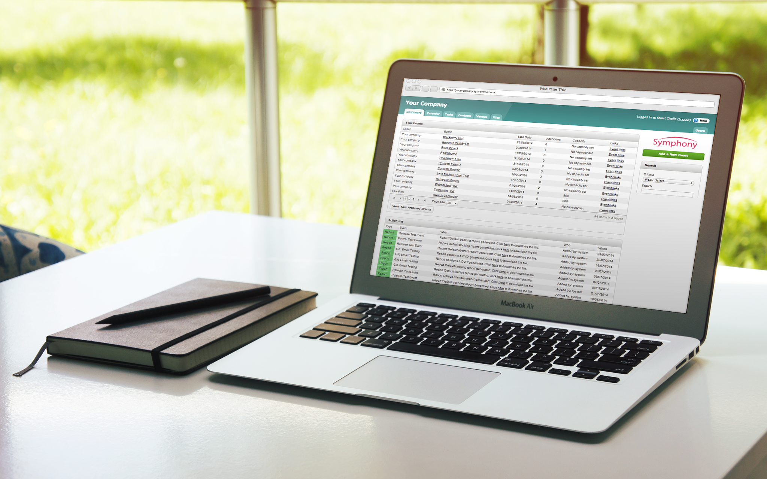
Email: Info@symphonyem.co.uk

